**How to connect the SQL Server Embedded Edition**

**We can create a Server Alias for the "MICROSOFT##SSEE" named instance.**

**1. Run "cliconfg" on the box from the command line or from Start --> Run**

**2. In the "SQL Server Client Network Utility" console, click the Alias tab.**

**3. Create a new Server alias.**

**4. Server alias: <ServerName>\MICROSOFT##SSEE**

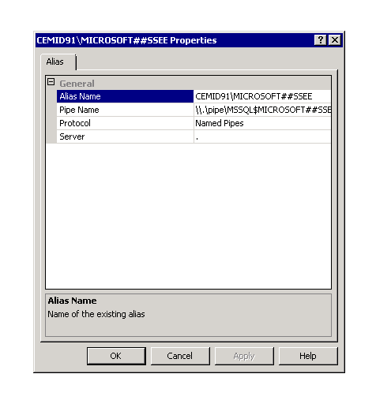

**5. Replace <ServerName> with the exact server.  
Network libraries: Named Pipes  
Server name: .\MICROSOFT##SSEE  
Pipe name:** **\\.\pipe\MSSQL$MICROSOFT##SSEE\sql\query**

**6. Then open SQL 2005 management studio, input <ServerName>\MICROSOFT##SSEE as Server Name.**

**Now you can use SQL 2005 management studio to connect to the SQL data for Sharepoint site successfully.**